INTERIM REPORT

OF

“CREDIT EVALUATOR THROUGH INTELLIGENT MODELLING”

FOR



Contents
◉

Chapter 1: Initial Situation and Goals 3 1.1 The initial situation 3
1.2 Project goals 4
1.3 Delimitation of goals 5

Chapter 2: System Application and System Environment 6
2.1 Prerequisites for the system to be used 6
2.2 User specification 6

Chapter 3: User Interfaces 9

Chapter 4: Functional Requirements 11
4.1 Activities
4.2 Inquires 11
4.3 Reports
4.4 System Administration 13

Chapter 5: Nonfunctional Requirements 27

Chapter 6: Exception Handling 29
6.1 Effects of various kinds of errors 29
6.2 Required system behavior upon errors 30

Chapter 7: Documentation Requirements 31

Chapter 8: Acceptance Criteria 31

Chapter 9: Glossary and Index

Initial Situation and Goals


.0
1

The chapter attempts to describe the initial situation of the project with reference to the requirements analysis. It also elaborates on the project goals and delimitation of these goals with respect to the system environment.
The initial situation

☒
1.1

- Investigation of the current procedures
The initial step was to carry out a study of the Initial Credit Evaluation Process in the bank. This was achieved by mainly interviewing the Manager and the Credit Officer at Commercial Bank, Kotahena Branch.
This customer evaluation process has so many routes and one of them is called “PAPER CHAMPS”. Each letter of the word has a particular meaning relevant to the facility requested. This allows the Credit officer / Manager a practical way of decision making in a systematic manner. The acronym is given below.

P - Purpose of Loan/OD
A - Amount of Loan/OD
P - Period
E - Exchange Regulations
R - Repayment

CHA - Character of the borrower
M - Mandate
P - Profitability of the related business
S - Security offered

The prospective borrower, a personal customer or a company, depending on the case, will be interviewed and related information based on the acronym will be collected. Each field represented in the above acronym may be further divided in to sub categories depending on the case.

i.e word ‘CHA’ – character of the borrower
This could further be divided as follows
(a).Data of Credit Information Bureau of Sri Lanka
(b).Status reports from other relevant banks
(c).Existing data from Commercial Bank
Once the required information are collected, those will be logically analyzed to find the creditworthiness of the borrower.

Random samples of credit applications were also analyzed to capture required information to design the database structure and the user interfaces. Different categories of Credit applications can be seen depending on the customer profile. (Individual, Proprietorship, Partnership, Companies & etc.) When the module is relevant to Individuals ,considered, basically Name of the borrower, Address, Date of birth, National Identity Card Number (NIC), Nationality, Civil Status, No. of Dependants and their ages, Income tax details, Monthly Income and expenditure, Assets owned, etc. are collected.

- Investigation of the current system
It was revealed that the initial credit evaluation process in the bank has not been streamlined or automated due to subjective nature of the process as well as the existing network’s inability to support such a process. Hence, after carefully studying the current procedures of initial credit evaluation process, it was decided to develop a new system.

The pros and cons of several technologies were also analyzed and decided to modularize the system into possible modules. After modularizing, it was decided to use component based development method. Considering the case tool support and the availability, UML was identified as the most suitable candidate for modeling the system.

Project goals

☒
1.2

- Prepare Project Proposal.
- Define scope of the system with a view towards addressing all possible functional areas within the allotted time frame.
- Study the procedures and ways of Initial Credit Evaluation in the bank.
- Research on component based development technologies with a view towards understanding of the true nature, the potential and the applicability of it within the proposed system.
- Gain a sound knowledge of SQL databases and Visual Basic component based development technologies.
- Prepare Requirement specification based on analysis of the problem and the findings of the literature survey.
- Design the system.
- Implement the new system.
- Critically evaluate the new system in order to identify possible performance issues strengths and weaknesses of the architecture.
.

Delimitation of goals
☒
1.3

System Application and System Environment


.0
2

The chapter attempts to describe the prerequisites that must apply for the system to be used and the specification of the number of users, the frequency of use and the jobs of the users.
Prerequisites for the system to be used

☒
2.1

Hardware requirements:

Server: Pentium III 1GHz,
384MB RAM
2GB Hard Disk space

Client: Pentium III 833 MHz,
128MB RAM,
150MB Hard Disk space,
Network Card

Software requirements:

Server: Window 2000 Server, SQL Server 2000 (Enterprise Edition)
Client: Windows 98 or higher OS, VB Run time.

Special requirements: Networking Accessories.

Note: Above are the minimum requirements.

User specification
☒
2.2

The system mainly caters for two categories of users (actors),
- Normal user
- Administrator.
There is no defined limit for the number of users in all two categories except for database limits.

- Normal user
Manager/Credit officer should be given Normal user passwords.
- Administrator
Administrator passwords should be assigned only to the Manager of the branch. He is supposed to do administrative work of the system.

User Interfaces


.0
3

User interface module defines all the user interfaces in the system. The module can be further subdivided as;
- Normal user interface module
- Administrator interface module.
The Manager/Credit Officer is a normal user who directly uses the system. User interfaces gathered through prototyping with the Manager/Credit Officer are modularized in the User interface module.
Administrator is only the Manager of the branch. Administrator is responsible of changing system parameters or logics.

Interface modules are planned to develop using Visual Basic, since the client prefers to communicate with the system using Graphical User Interfaces. Sample logon screen and a Normal user activities screen are captured below.

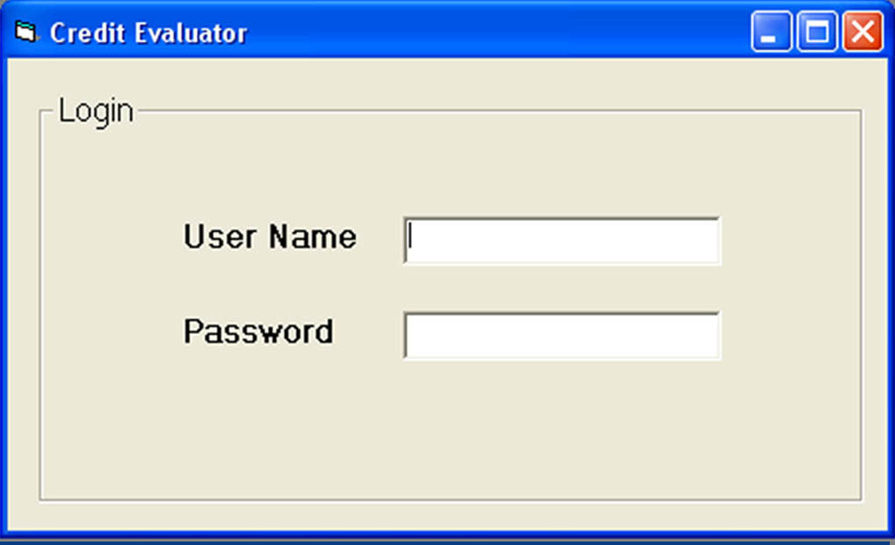

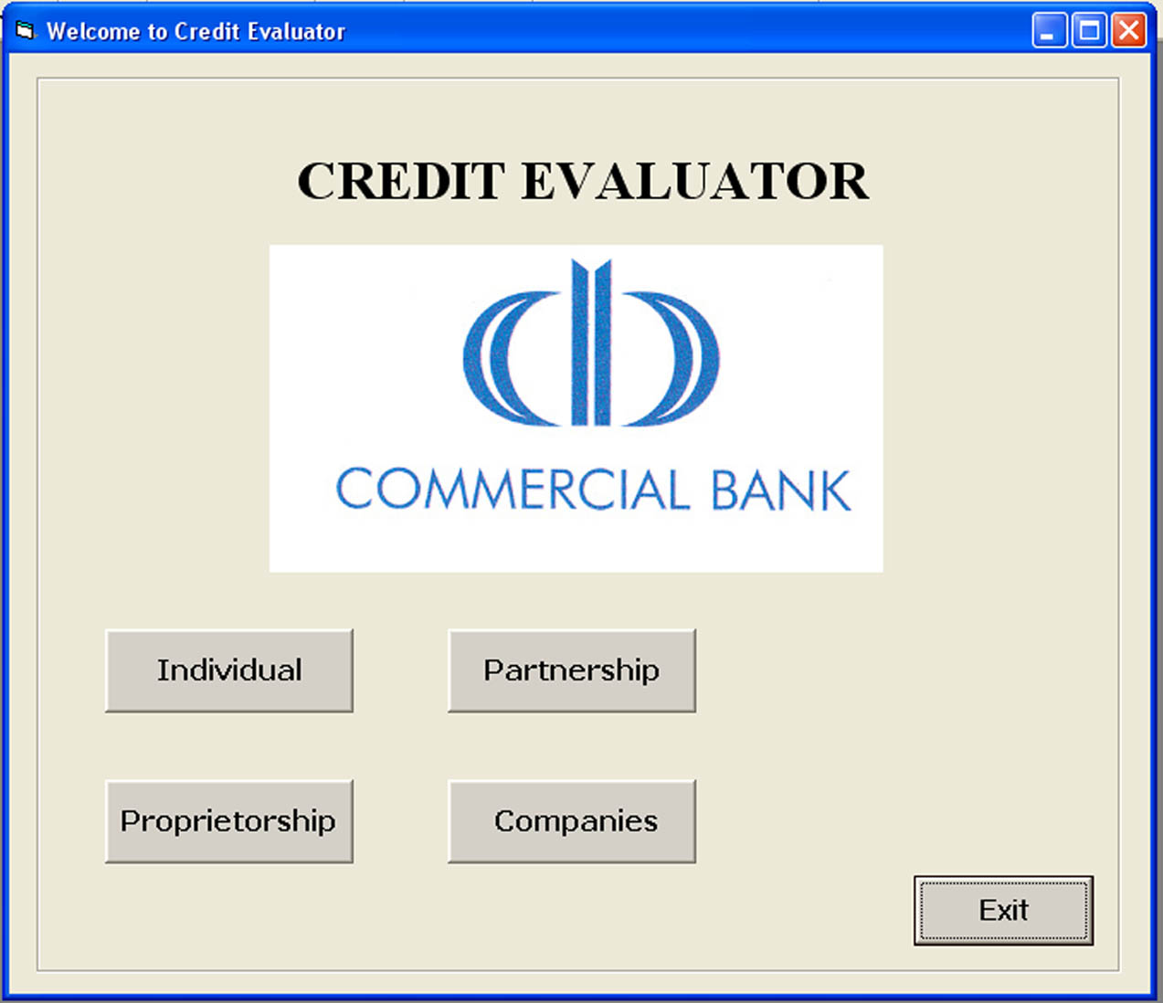
Functional requirements


.0
4

After analyzing all the requirements, the system functionalities have been grouped as Activities, Inquires, Reports, and System administration. All the required functionalities under each category are described in following sub headings as expected by the user.
Activities

☒
4.1

- System shall handle the “Collecting Customer Information” process
The process shall allow user to input Customer Information through the user interface. This process is allowed for normal users and administrators as well.

- System shall handle the “Edit Customer Information” process.
The process shall accept the identification number of the customer and extract, display the relevant customer details, and let the user to edit necessary information. After user confirms, the process shall update the database. This process shall not allow for Normal Users.

- System shall handle “Input new advances granted” process.
The process shall allow user to input new advances granted and update the database after user confirmation.

- System shall handle the “Black List” process.
The process shall accept black listed customer identification number and extract, display the relevant details, and let the user to mark or unmark as a black listed customer. After user confirms, the process shall update the database and shall not allow further advances for a blacklisted customer. The process shall not allow for Normal Users. Black listed customer details can be found after inspecting the non performing advances of the branch.

Inquires

☒
4.2

- Customer Activity
The process shall accept customer identification number and display the details of his/her last visits and outcomes.

Reports

☒
4.3

4.2.11

- System Audit
Any changes done to the system parameters, change of special customer tags (black list, remarks), and other special activities shall report through the audit report. The report shall include the user NAME, type of change, time, date and a small description.

- Black Listed Customers
The report shall include all the black listed customer details, such as customer identification number, name, address, telephone number, email address, etc.

System Administration

☒
4.4

All the following System Administration functions shall allow only for Administrators.

- User Management
The process shall allow adding, modifying or deleting any user/user details and storing in the database.

Nonfunctional Requirements


.0
5

Since the system is for a bank, the data security, reliability and availability become very important aspect in the project. The proposed system is to be used MS-SQL database. Therefore the database itself has some built-in features to address some of the critical issues. Some of the techniques that should use to overcome these issues are listed below.

- Utilize certain cryptographic techniques
- Assign certain functions to different modules
- Check data integrity for critical variables.

Reliability and the availability of the system are to be achieved through component based development, because the individual components can be tested separately and again as a whole to eliminate error at their origin.
Since the client already has decided to use the system under Windows 2000 platform, the portability of the system is not a critical problem.
Correctness of the system is already clarified to some extent after demonstrating some sample operations, used with MS-Access database, to the Credit Officer at Kotahena branch. Further the gathered requirements have already been cross checked with their Manual Procedures.
Almost all the transactions shall be processed in less than 2 seconds. Efficiency plays a major role when considering customer service, therefore code reuse, use of minimal number of code to perform functions, efficiency of code and use of mathematics should be considered carefully.
The system should keep provision for function code changes with minimal affect to other functions. The system shall perform all of its functions very accurately, without any runtime errors or malfunctions.
The system shall test from the initial design stage. All the components also should test extensively including their interfaces. It shall pass all the test cases provided by the bank.
The usability of the system should achieve through user interface prototyping. All the required user interfaces have already been captured through prototyping. The system shall produce user manuals as well.

Exception Handling


.0
6

The chapter describes the effects of various kinds of errors and the required system behavior upon occurrence of an error.
Effects of various kinds of errors

☒
6.1

There could be five types of possible errors;
- Requirements errors
Errors in identifying user requirements fall into this category of errors. Since the system is to be newly done, there is a high potential of occurring requirements errors.
- Design errors
Design errors occur when the designed system is not compatible with user requirements. Bad designs may lead to performance degradation, maintenance problems, enhancement issues, implementation problems, etc.
- Coding errors
This type of errors leads to runtime errors and catastrophic failures of the system. Source code should be tested from the scratch to eliminate this type of errors.
- User documentation errors
Errors in user documents, such as documents describe what are not present in the system, incorrect operations, etc, fall into this type.

- Bad fixes, or secondary errors introduced in the act of fixing a prior error
Correction of an above error may lead to secondary errors, if the error correction is not properly managed.

Required system behavior upon errors

☒
6.2

- Requirements errors
User requirements have already been identified up to a great extend after interviewing the manager and the credit officer of Kotahena branch. However all the requirements errors should be identified at the end of requirement analysis and corrected before the design stage.

- Design errors
System should be modeled according to UML. The design should be highly mathematical oriented to enhance the efficiency. All the system design should be checked against the requirements

- Coding errors
The system should subdivide into modules and develop module wise. All the sub modules should be tested as and when coding, modules must be tested when integrating sub modules and finally the whole system should be tested when integrating all the modules. Any kind of an error should not affect the database or should not create a monetary loss to the bank. In case of an error at the runtime, it should be alerted immediately in an understandable manner to the user. The system should not halt in any case and it should be able to function as expected by the user.

- User documentation errors
System documentation should be well organized, structured and easy to understand. The system documentation should be done at relevant stages as the project commences. The system documentation including the final dissertation should always change when a change happens to the system. Updating of user manuals and system manuals should properly carryout when changes are done even after the delivery of the final product.

- Bad fixes, or secondary errors introduced in the act of fixing a prior error
A change or a fix should be always followed by a secondary error check.
Documentation Requirements


.0
7

The system should deliver the Project Description Form, Interim Report and the Final Dissertation. All the documentation formats should be well structured and formatted. All the documents should be submitted on time as required by UCSC.
The Project Description Form should contain an overview of the proposed system, work breakdown and the project schedule.
Interim report should be submitted after the requirement analysis. It should contain all the required system functionalities, etc.
Final Dissertation should contain all the system manuals, test plans, user manuals and all the other documents related to the system.
Acceptance Criteria


.0
8

At every stage the system should be accepted by the client. Technical reviews and some presentations have already been done after the requirement analysis, to verify the gathered each of functional and nonfunctional requirements. All the user interfaces were prototyped and gathered with the extensive user involvement with their acceptance.
At the system design stage, any unclear or doubtful functionalities should be prototyped to the client for acceptance. At the end of design stage, system should be accepted against the requirements and performance by the client. When coding, each module should be demonstrated to the client for acceptance.
Finally the system should be tested by the client before acceptance. The system also pass with the test data and the selected actual data supplied by the client. Passing all, the system will be accepted by the bank and will be implemented initially at Kotahena branch.

